Private First Class Byron L. Stanton
Company B, 1st Battalion, 116th Infantry, 29th Infantry Division
Omaha Beach

Draft Registration Card
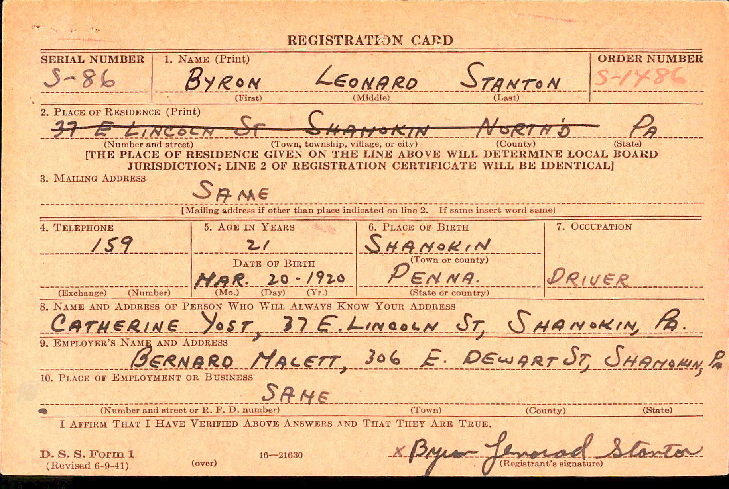

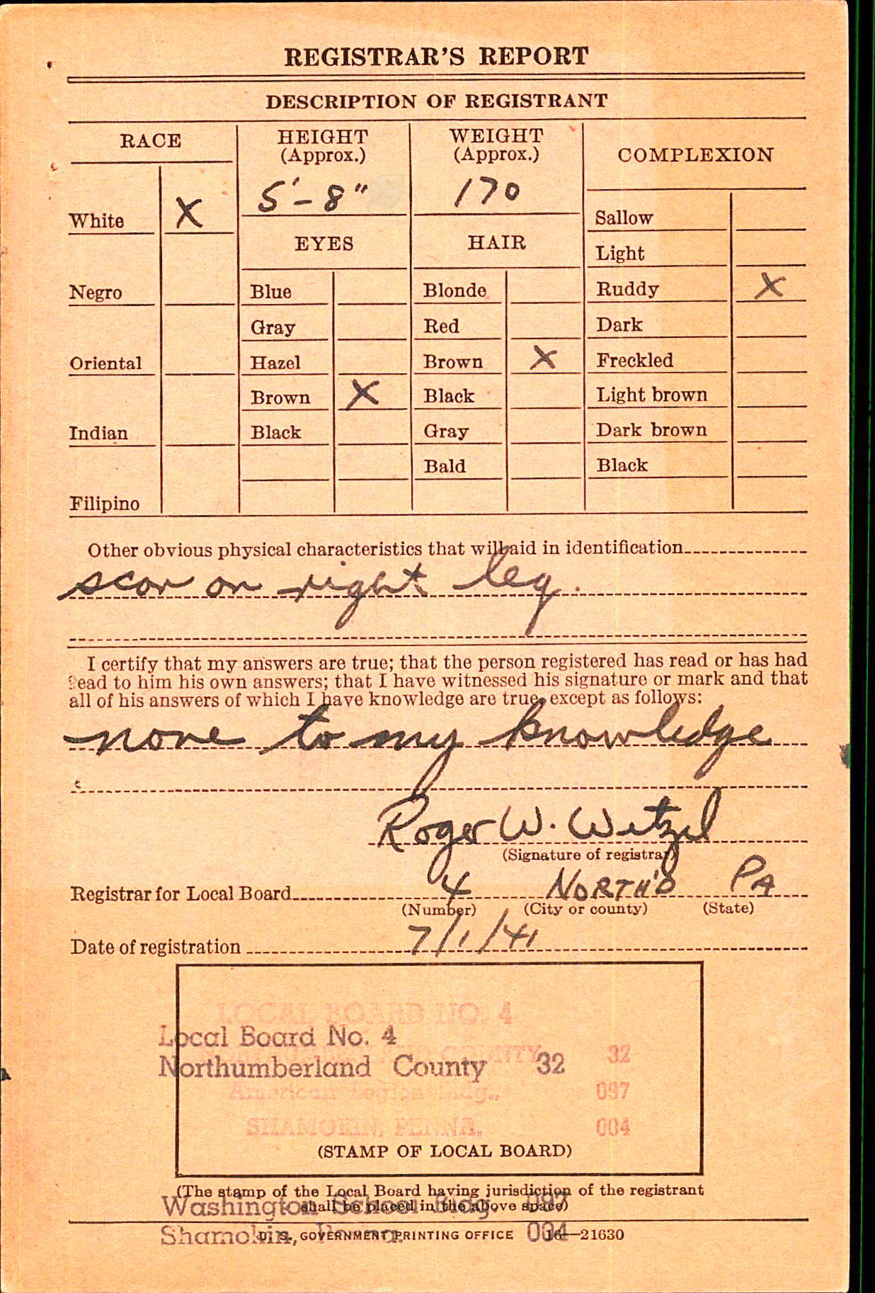
Pension Application
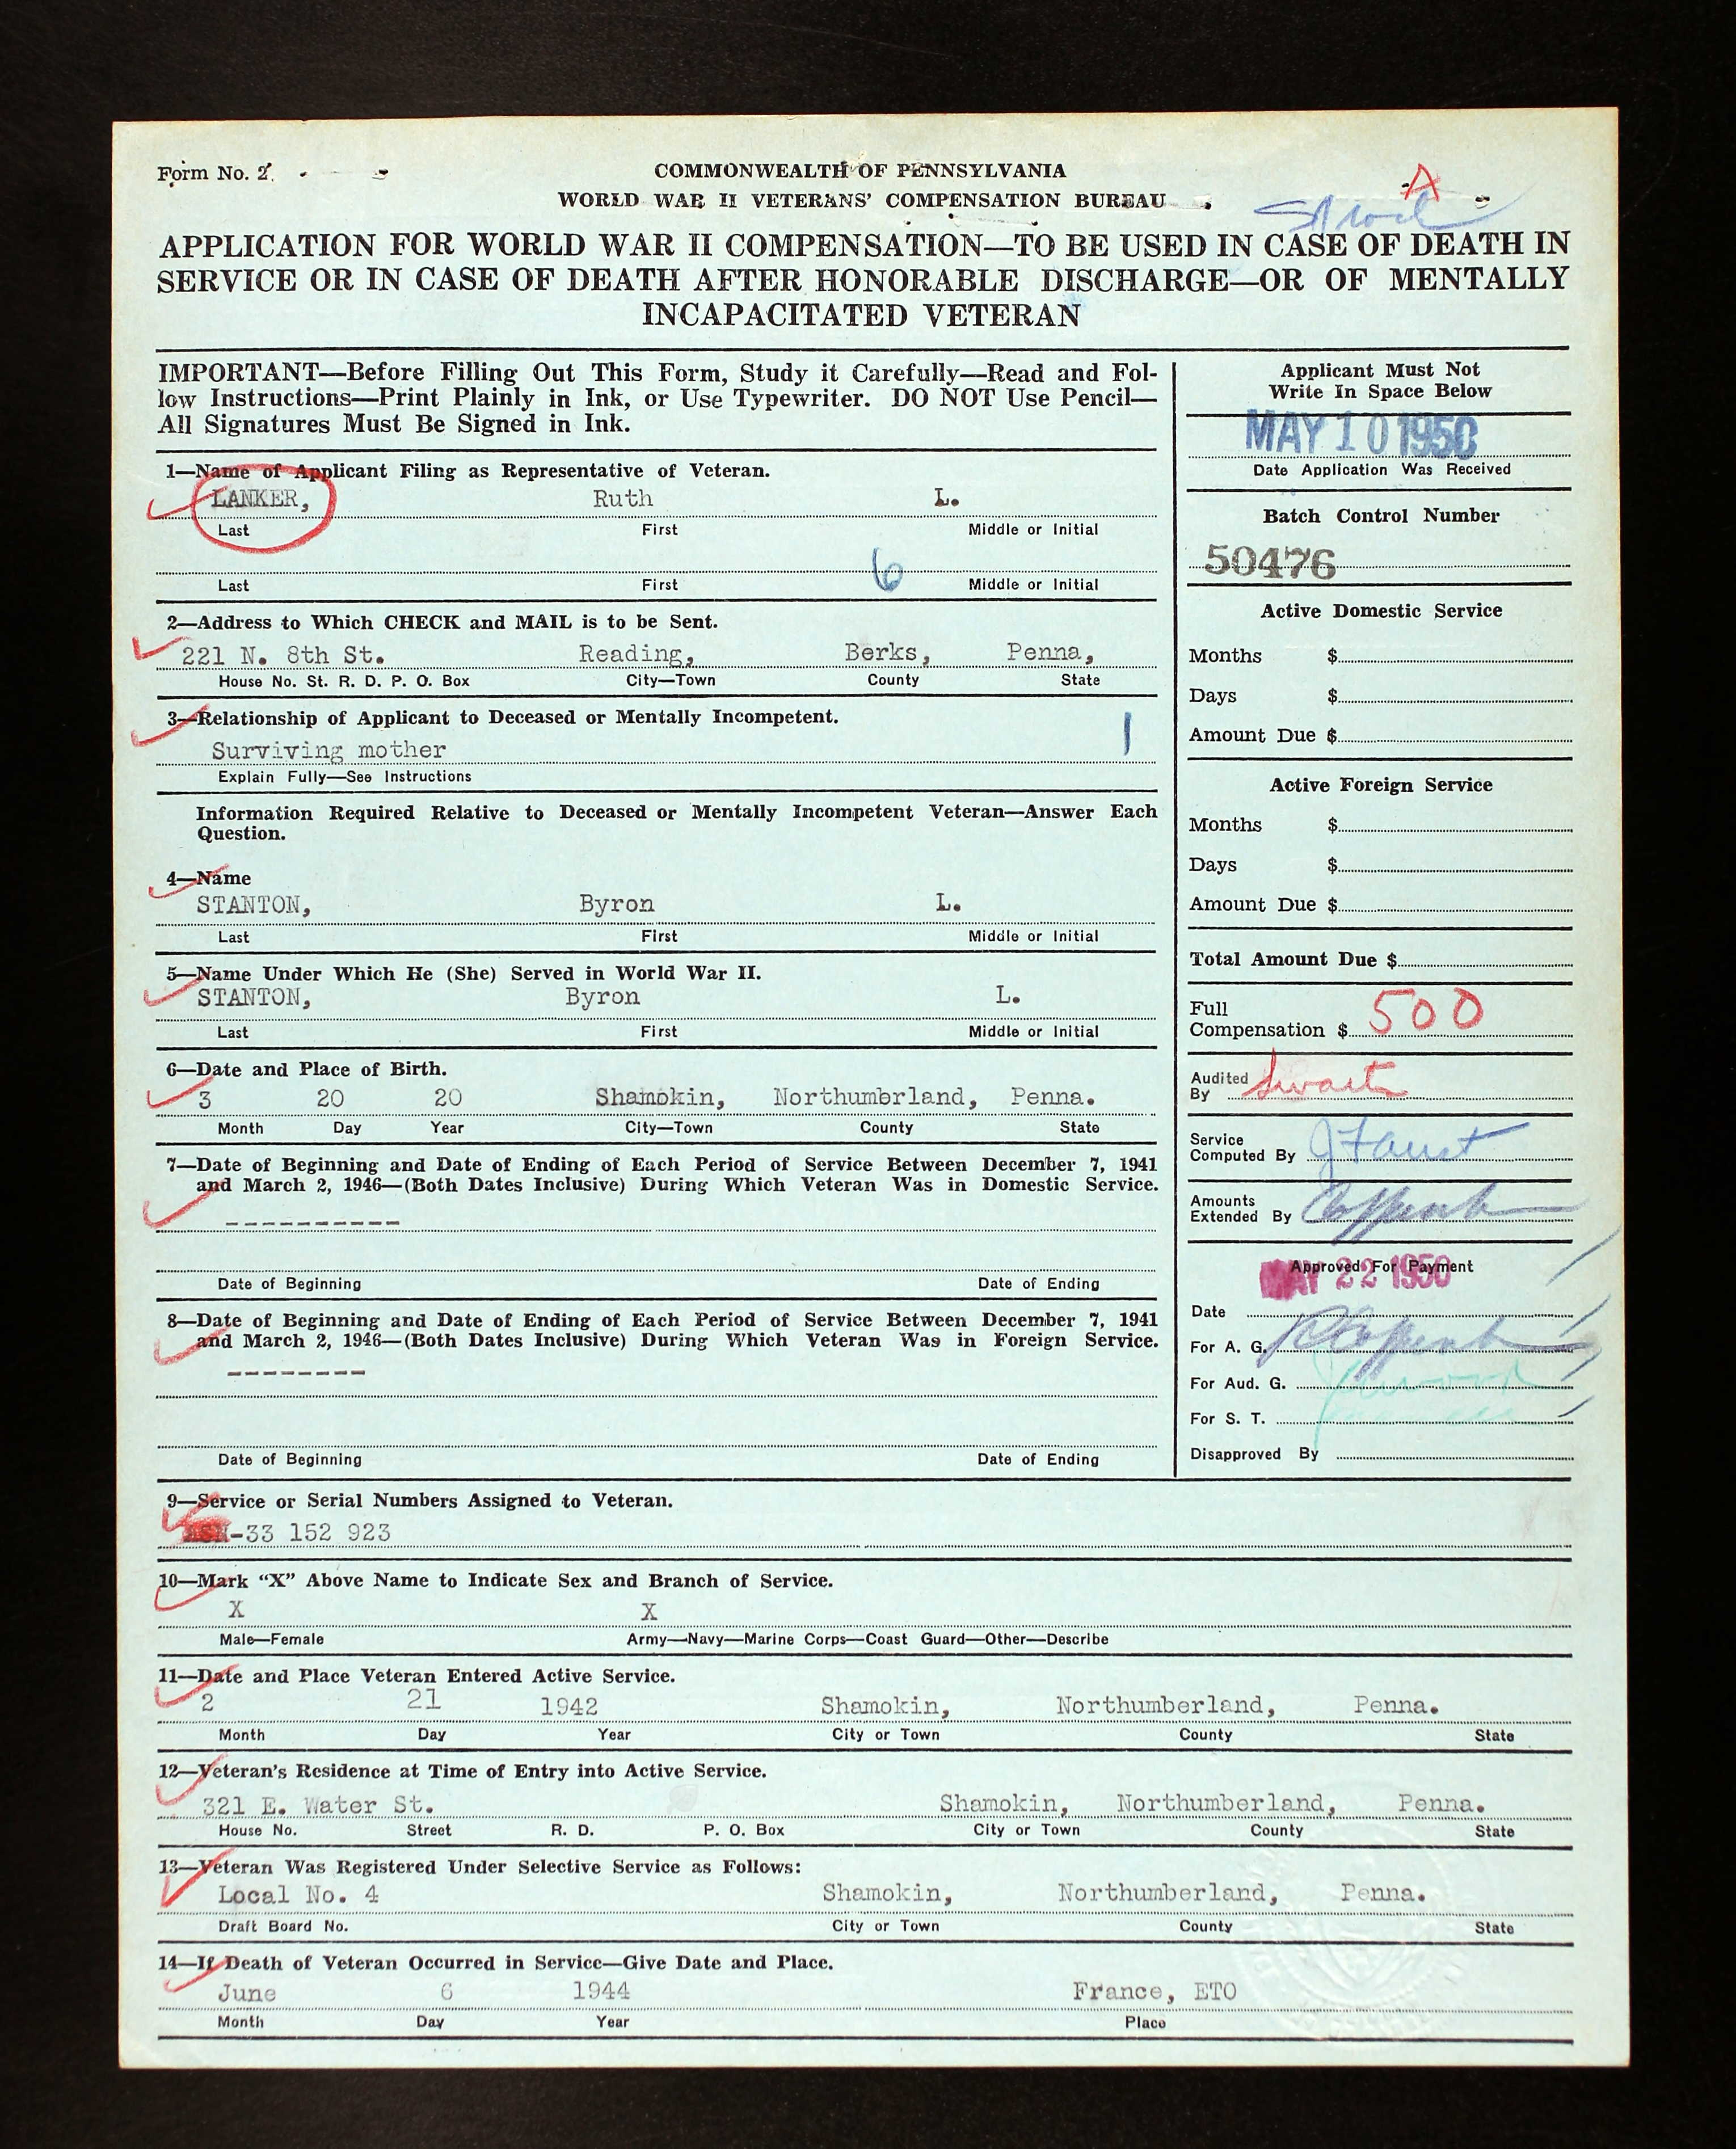

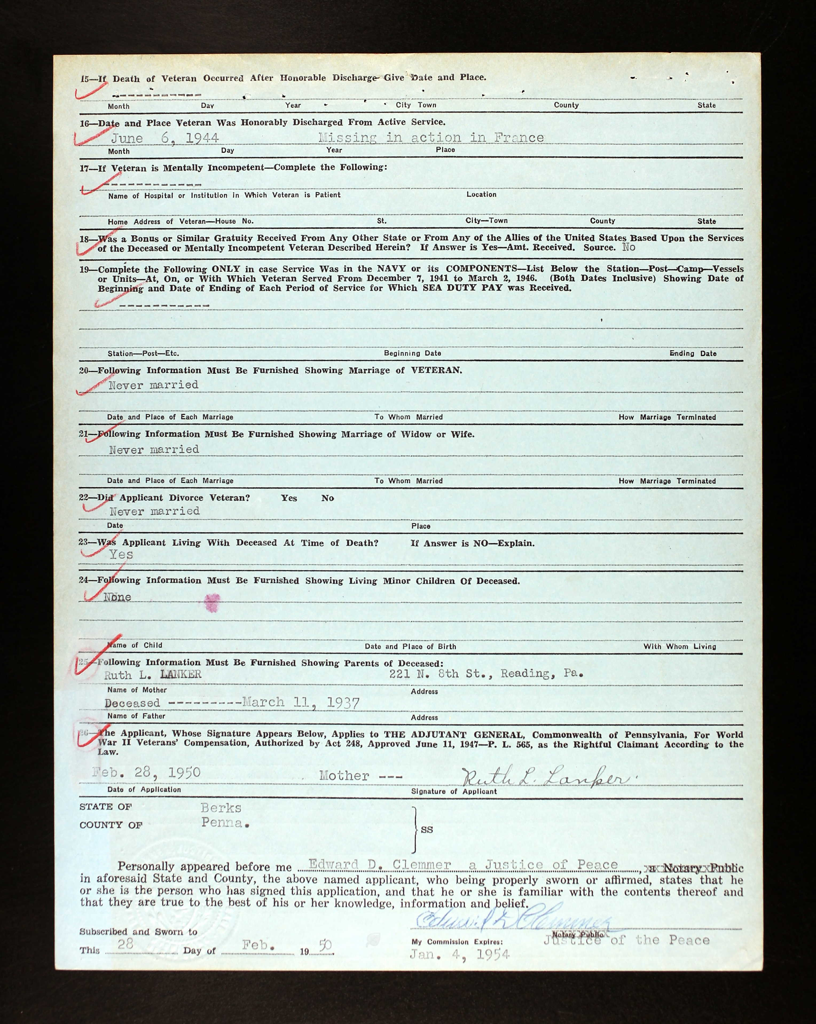

Shamokin News Dispatch, March 11, 1937
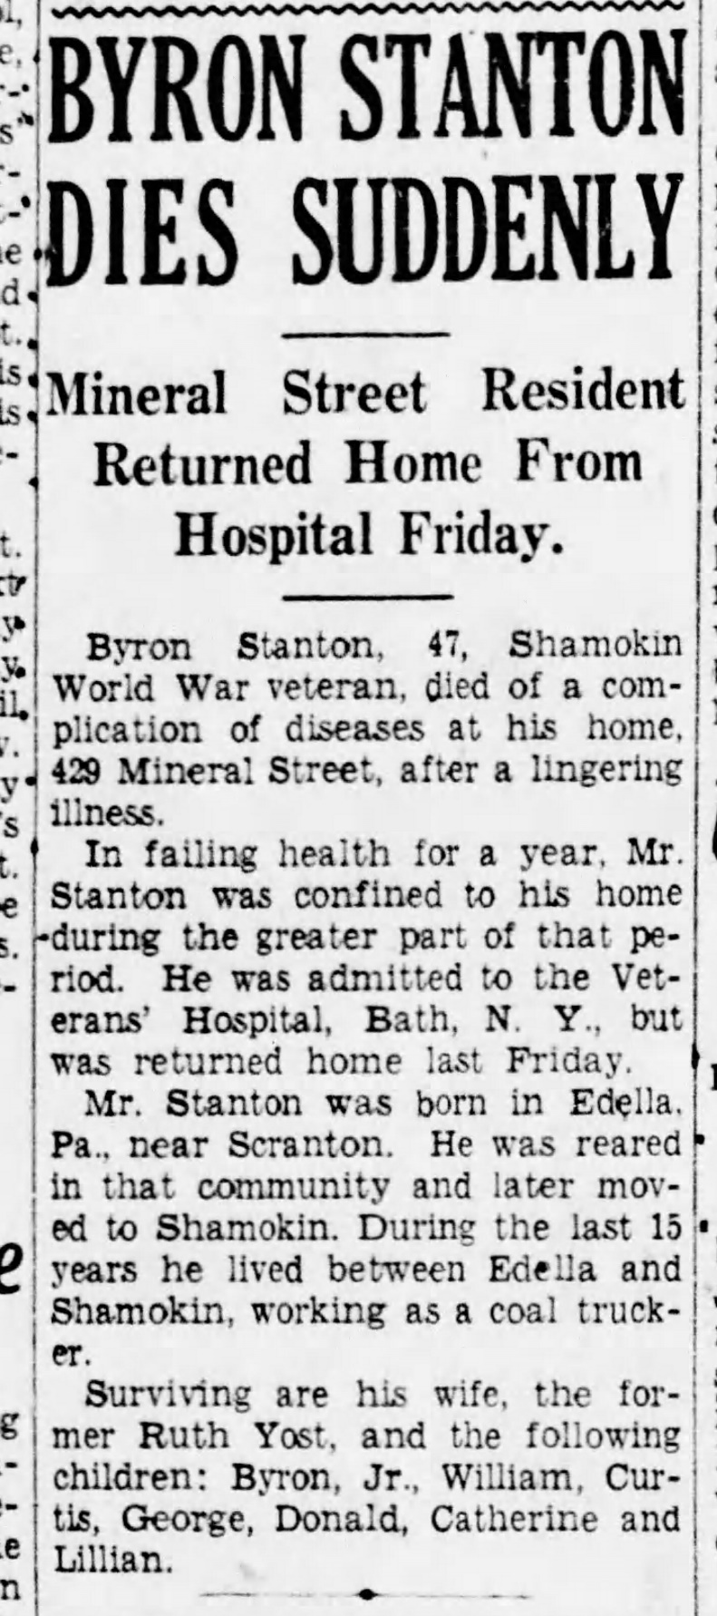

Shamokin News Dispatch, May 4, 1942
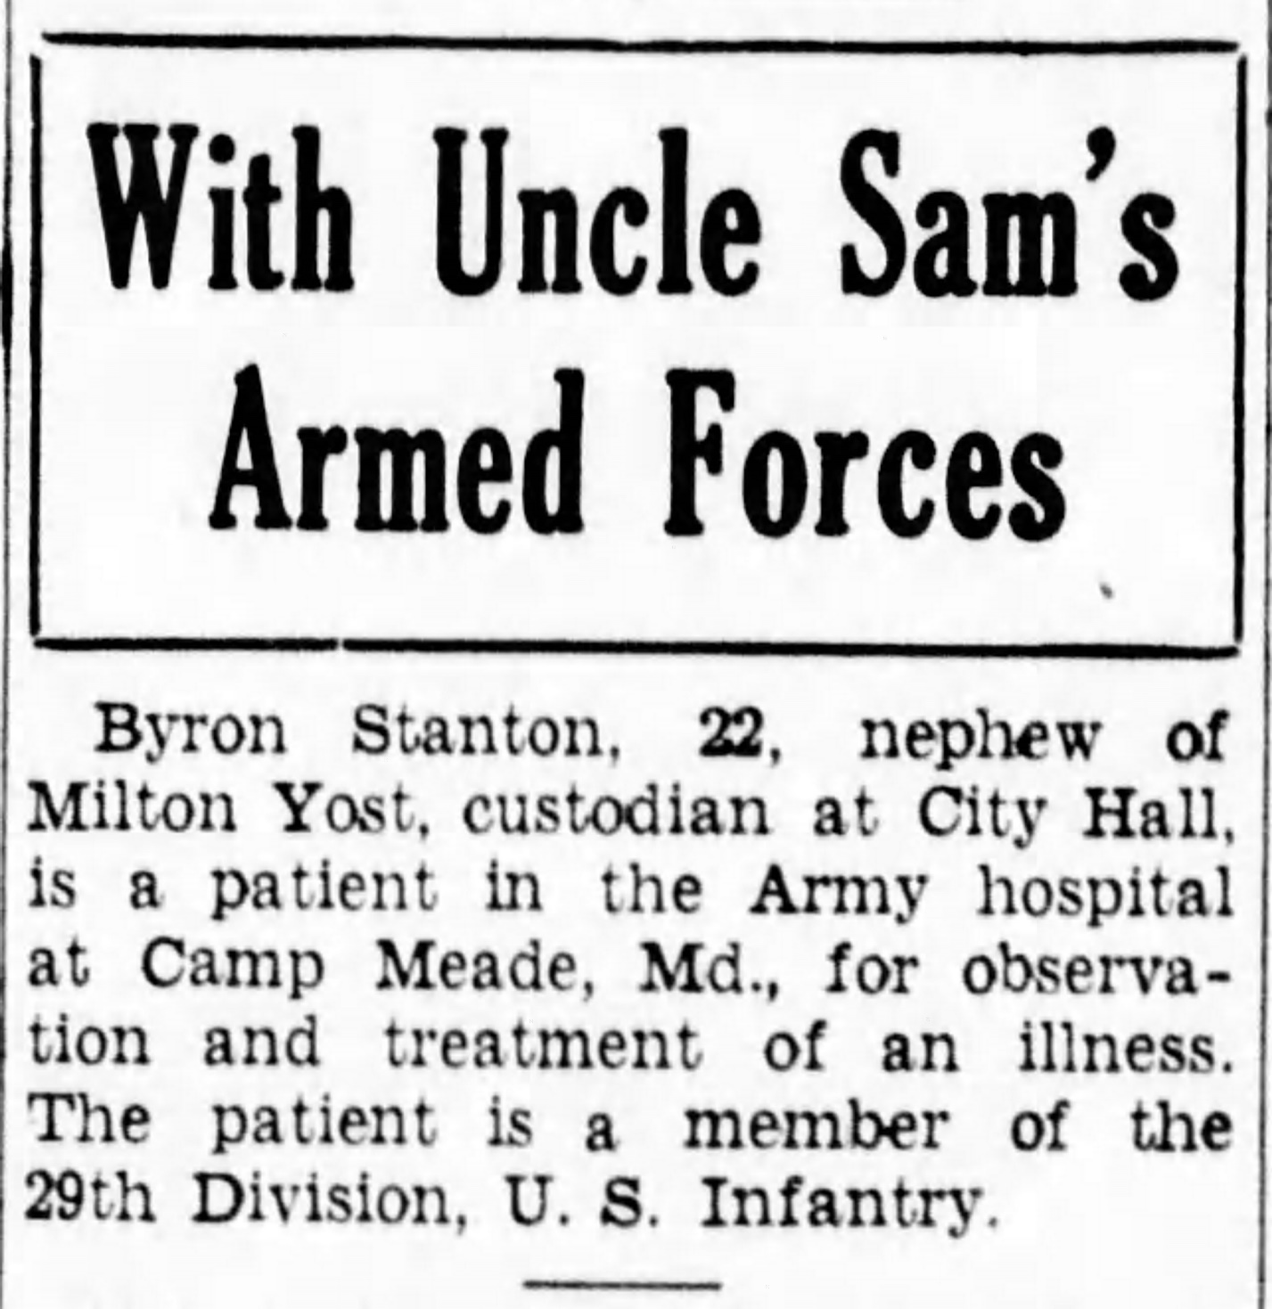

Shamokin News Dispatch, July 19, 1944
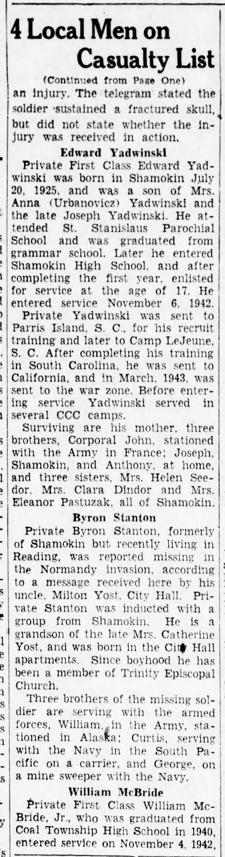
Daily Item, Sunbury, PA
August 7, 1944
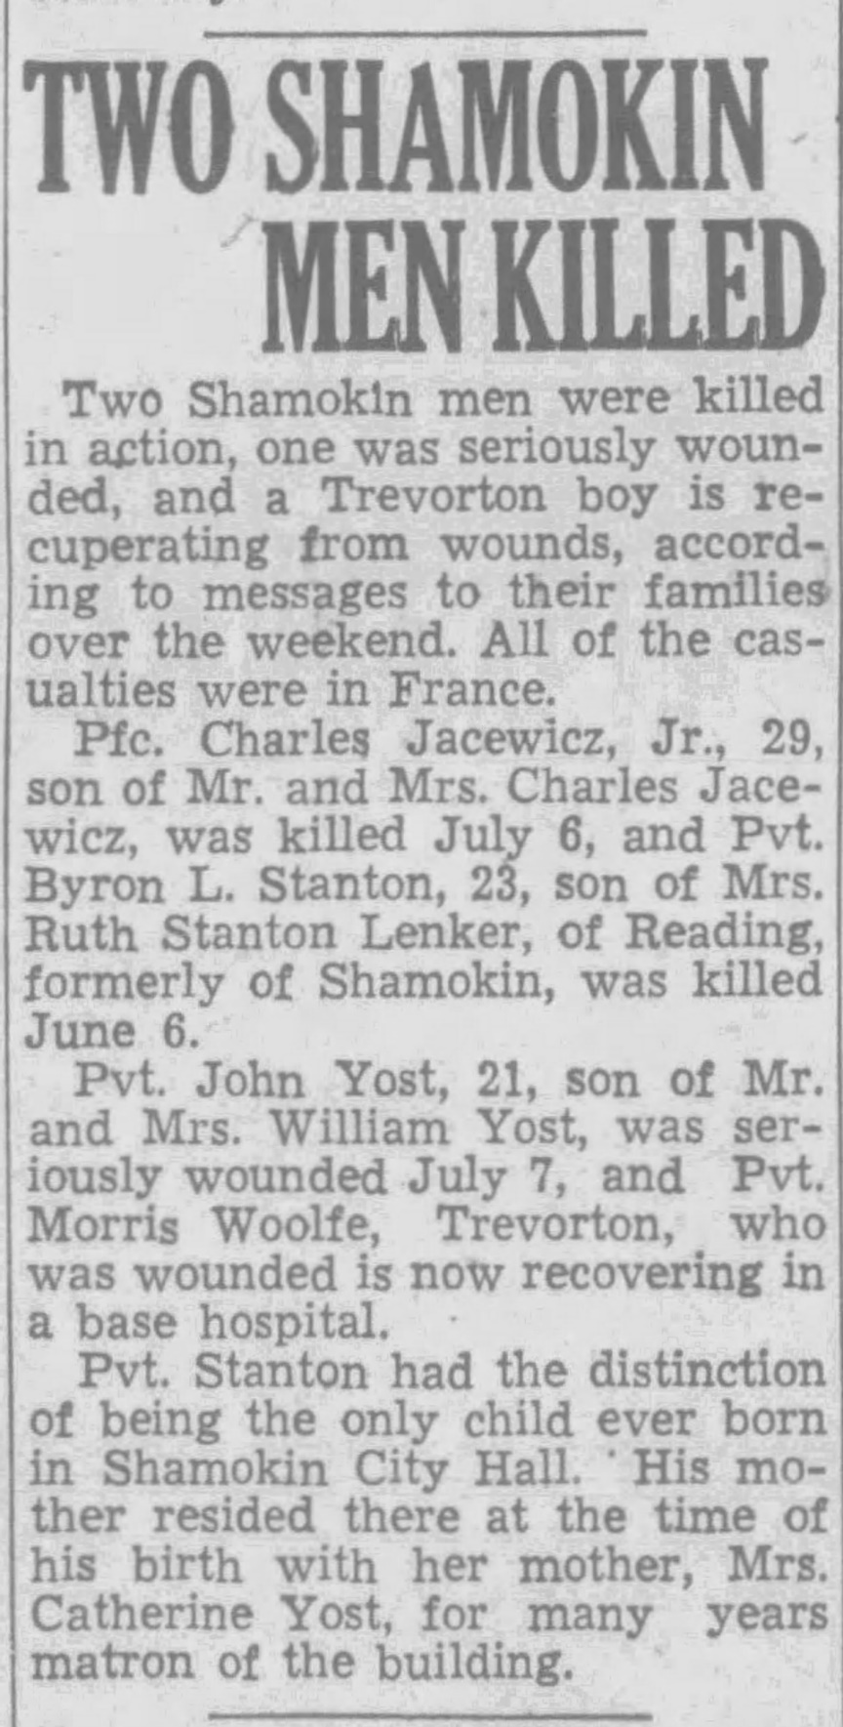
Shamokin News Dispatch
August 7, 1944
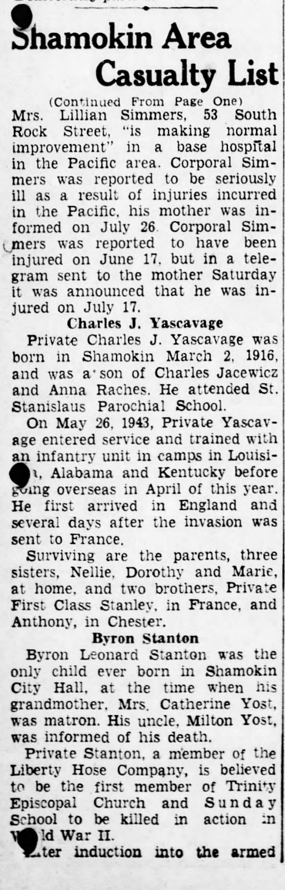
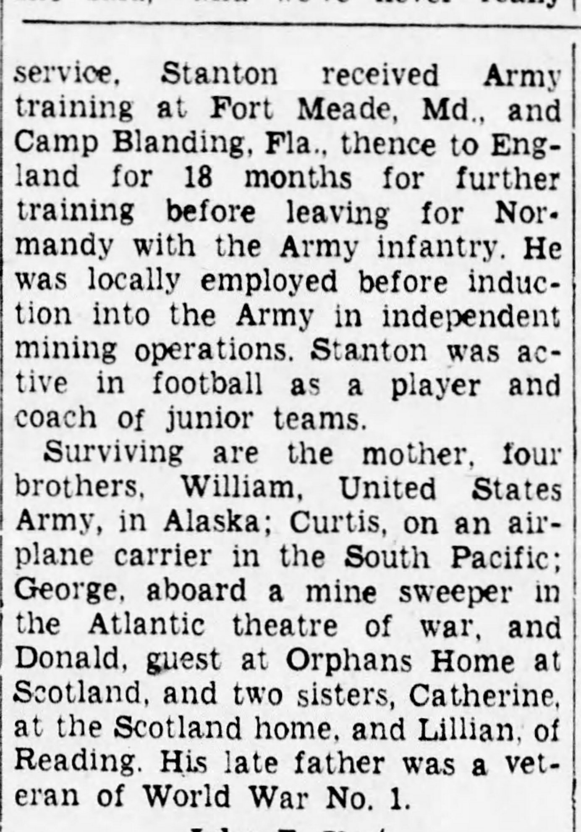

Shamokin News Dispatch
August 21, 1944
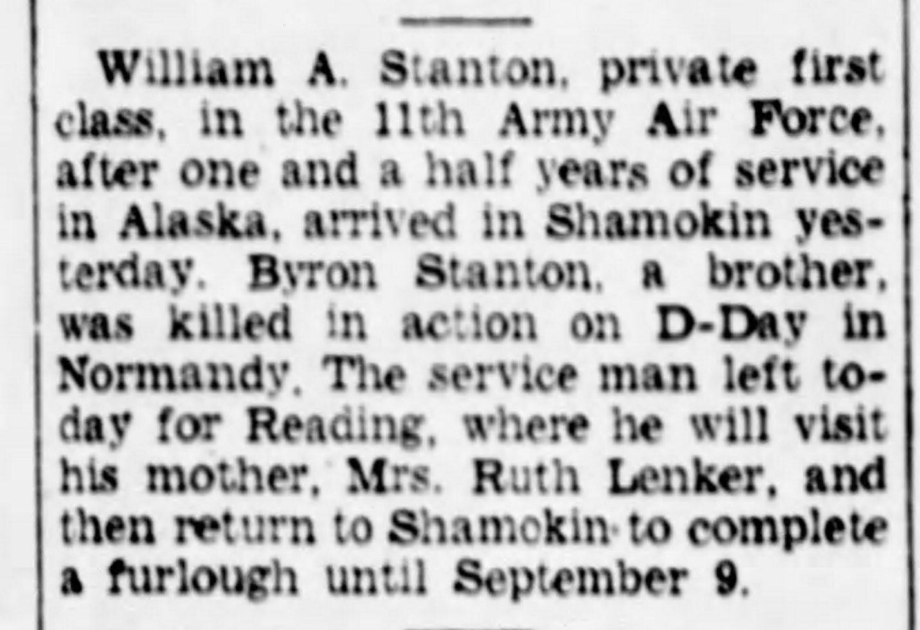

Shamokin News Dispatch
September 22, 1944
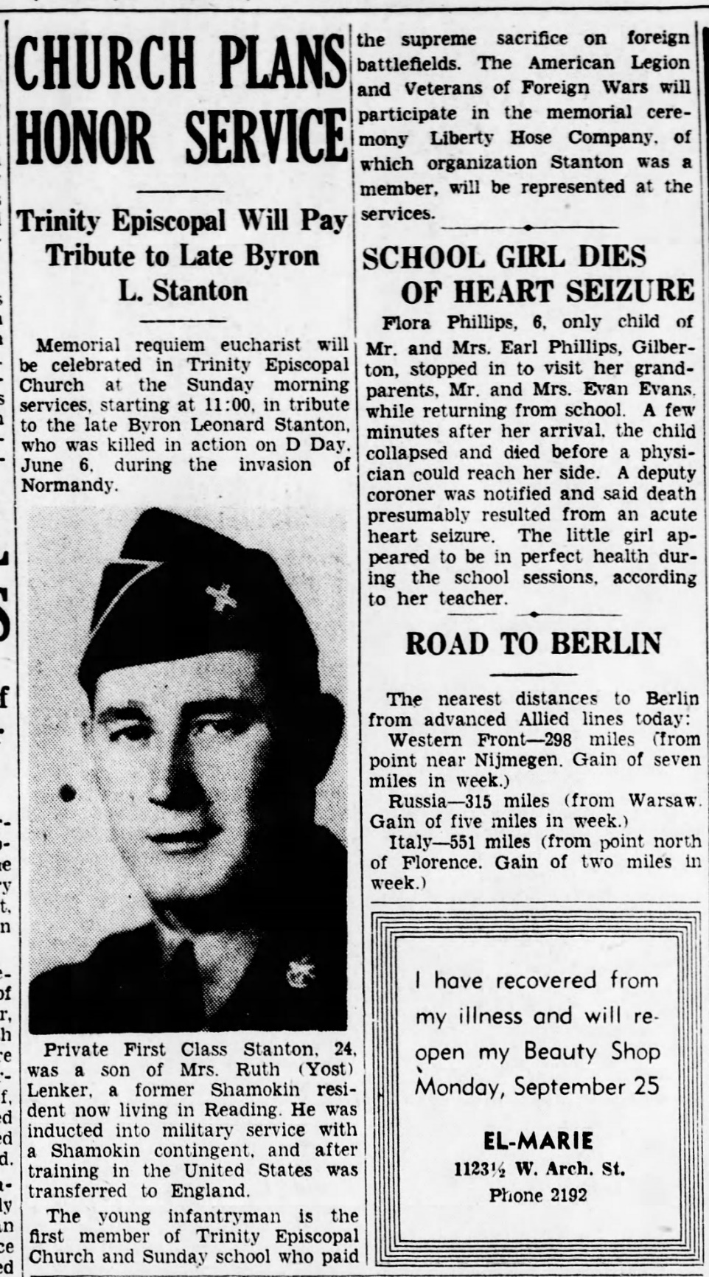

Shamokin News Dispatch
December 19, 1944
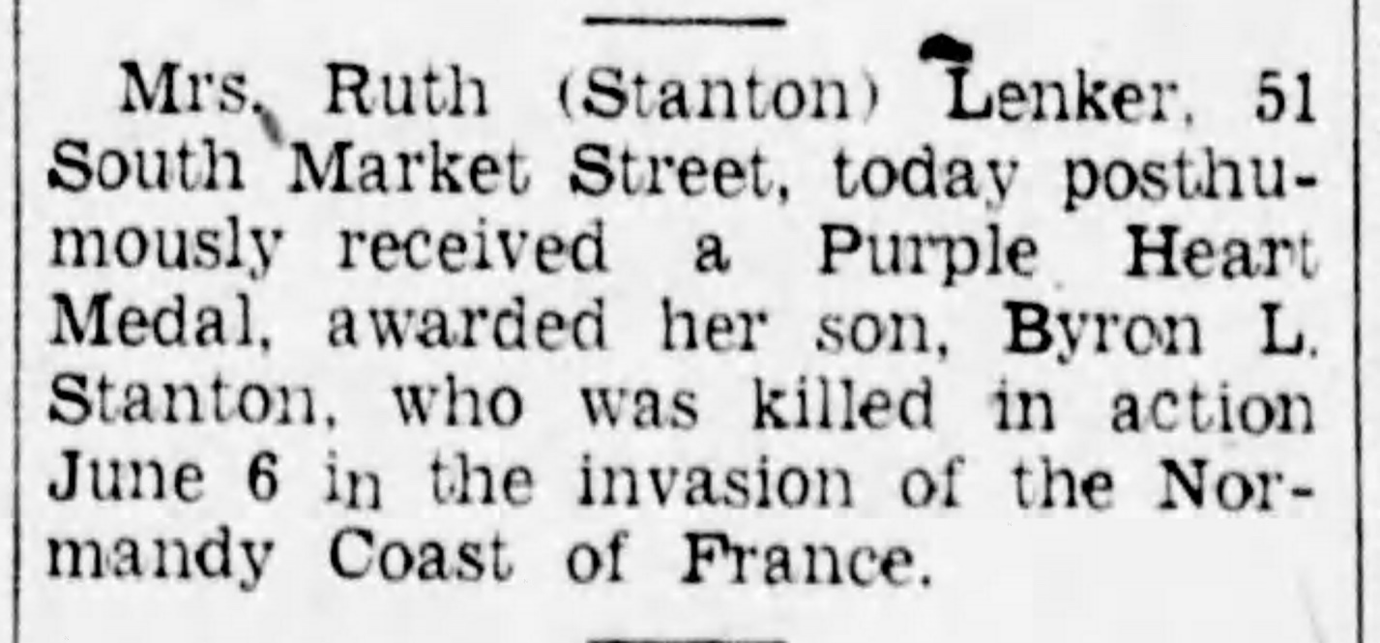

Shamokin News Dispatch
December 17, 1947
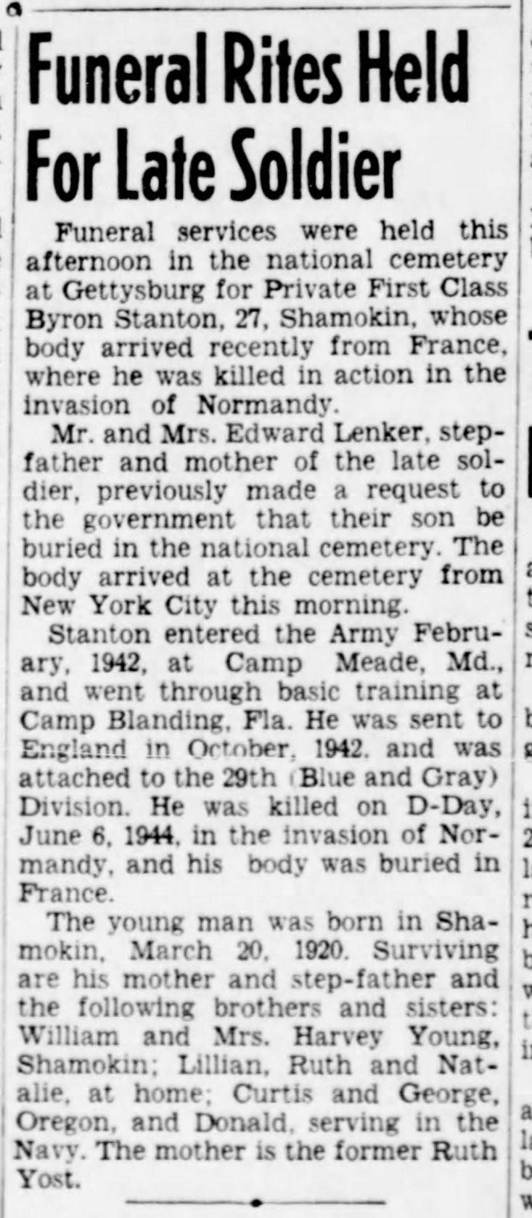

National Cemetery Interment Form
